PROFILE SECRETARIAT

Dr Bernard Kikaire – Scientific Liaison Officer/ HIV Node Coordinator

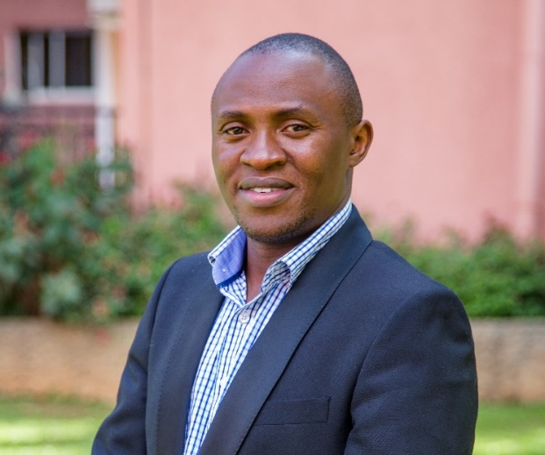

Emily Nyanzi Kabuye – Project Manager

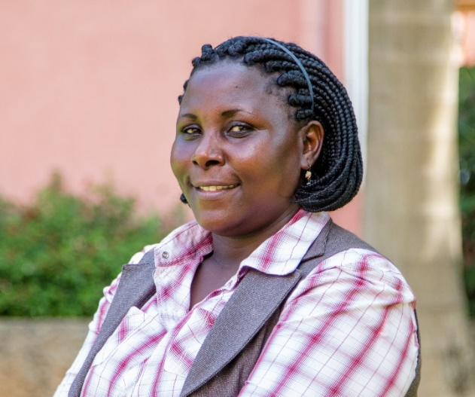

Emily Nyanzi Kabuye is the Project Manager for the East African Consortium for Clinical Research (EACCR2) from July 2010- to date. The EACCR 2 is one of the capacity building programs at UVRI, funded by the European and Developing Countries Clinical Trials Partnership (EDCTP). As a Project Manager she Co-ordinated, collated and harmonized the grant writing of the Eastern African consortium (EACCR2) to the EDCTP2 call on Networks of Excellence and had it submitted for the 2.9 million euros; coordinated and completed 2019-2015 work plans for Uganda as a Participating State in EDCTP Association including the required financial and technical reporting.

Emily was Co-PI and coordinator of the Canada Africa Prevention Trails Network (CAPTN) with Five sites in Eastern Africa 2009-2014 and she was part of the Research project team for the Adolescent HIV Prevention Strategies in Entebbe (ACERE) of $ 35, 000 to UVRI by the Canada-Africa Prevention Trials (CAPT) Network Dec 2011); the technical coordinator International Association of National Public Health Institutions (IANPHI) at UVRI 2010 -2012. Before that Emily worked with the Ministry of health Uganda in the health policy and planning department 2005- 2010 working closely with the commissioner planning on as the technical assistant on the proposed National Health Insurance Scheme (NHIS) and DANIDA projects were she coordinated District Planning and regional Area teams for mentoring and support supervision. While there she achieved as reviewer for the of the poverty spatial maps for water and sanitation for WB, MFPED and Uganda Bureau of statistics 2008 and National Health Accounts team 2007 working closely with WHO Country Office and won the short-term Grant of ($50,000) on Institutionalization of National Health Accounts in Uganda to MoH and Makerere University School of Public health with support from the Rockefeller foundation through WHO –Geneva

Emily Nyanzi Graduated with a Masters in Economic Policy and Management (EPM) 2006, Makerere University, graduated with a Post Graduate Diploma in Computer Science with specialised interest for Relational databases in 2003 and graduated in Economics and Education in 1997 all from Makerere University. Emily has a passion for seeing research evidence benefiting communities and up lifting them from poverty and policy guidelines

Saidat Namuli Musoke, Project Administrator

Ms. Saidat Namuli Musoke, Project Administrator EACCR-2 /EDCTP2 earned her Bachelor’s Degree in BA from Makerere University, Post graduate diploma in Project planning and management and Masters (on going) in Public Administration and Management Uganda Management Institute. She is one of the staff who worked on EACCR-1 2010-2015. Ms. Saidat Namuli has been working as an administrator for several years as well as supporting in project management in EACCR-2 todate. Her work is supported by grants from the European and Developing Countries Clinical trials partnership.

Janet Nanseko Musoke- Project Administrator

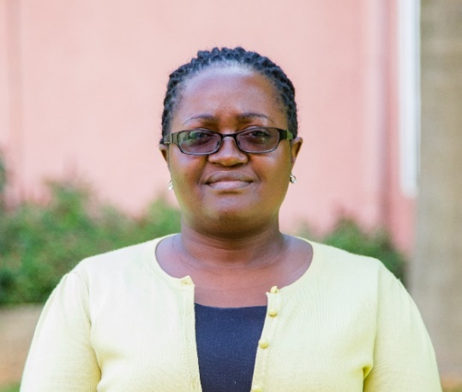

Joined the project in October 2018 as Project Administrator. In this role she supports the day-to-day general administrative tasks of the project,with a specific focus on supporting the activities of communications and coordinating travels. Janet holds a Bachelors degree in business administration and a diploma in Systems engineering.

Profile Dr. Annet Nanvubya – Reciprocal Monitoring Scheme Coordinator

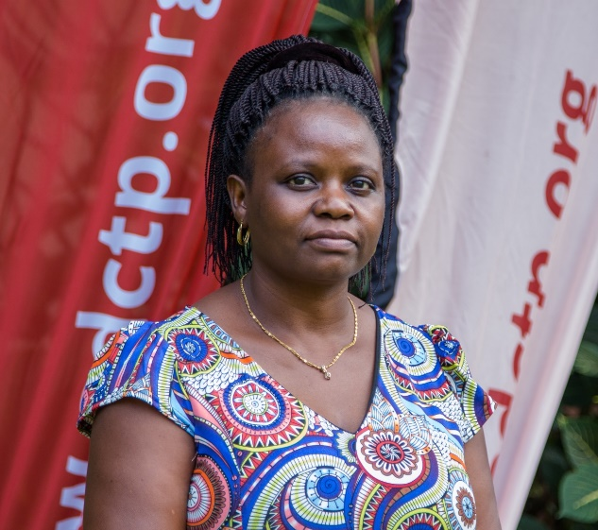

Dr. Annet Nanvubya, (MBChB, MPH) currently the Clinical Trials’ Manager for UVRI-IAVI HIV vaccine Program and Coordinator for EDCTP/EACCR2 Reciprocal Monitoring Scheme. Dr Nanvubya is a Medical Doctor, Researcher and clinical trials’ Monitor, certified and trained Monitor by WHO/TDR. She Coordinates a Reciprocal Monitoring Scheme (RMS) which was initiated by the East African Consortium for Clinical Research (EACCR) and funded by the European and Developing Countries Clinical Trials Partnership (EDCTP) for strategic quality management of health research in Africa. Dr Nanvubya has seen the RMS scheme grow to 25 trained and accessible regional monitors. The monitors are experienced health professionals who monitor trials using standardized tools in mutual cross-site monitoring visits as a planned part-time activity.
Dr Nanvubya also works with UVRI-IAVI HIV vaccine Program as the Clinical Trials’ Manager. She has participated in several IAVI funded phase 1/II HIV vaccine trials. She has provided substantial clinical support for many field based studies which helped to document the HIV infection rates in fishing communities along Lake Victoria in Uganda. She is also actively involved in clinical care and management of research participants for all the clinical trials conducted by the UVRI-IAVI HIV vaccine program and passionate about Reproductive health and HIV/AIDS Biomedical research.
She is currently pursuing a PhD in Medical Sciences from the University of Antwerp in Belgium.

Contacts: +256772592717/+256706431334
WhatsApp: +256771006974
Email: ananvubya@iavi.or.ug

